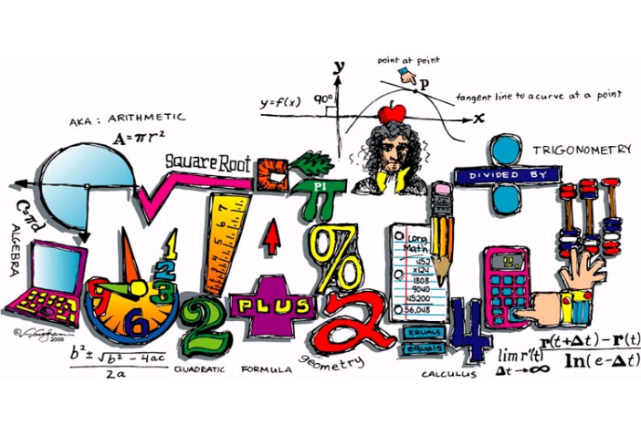
Holy Name Elementary School
Mrs. Kaylyn Riner
Grade 6-8 Mathematics Teacher
Email: Khines@holynameelementary.org
Website: http://mrsrinersmathsite.weebly.com/
Course Description: A deeper understanding of previous elementary mathematical concepts cross connected with various middle school mathematics and real-world simulations.
Course Objectives:
- Solve equations and inequalities
- Compare, add/subtract, multiply/divide decimals, integers, rational numbers, percents and fractions
- Create ratios/proportions and solve for them in problems
- Analyze geometric problems and solve for them
- Create and solve problems about probability
- Analyze data and statistics
- Evaluate graphs and linear functions
- Graphing
Instructional Approach: In this class students will use their skills in note taking and reciting class work/homework. Students will also learn with the help of a new computer-based series called Get More Math, and a few projects throughout the year.
Materials Required:
- 1 ½ - 2-inch binder, with pockets on the inside
- 5 pack of tab dividers, in the binder
- Notebook or Loose Leaf
- Calculator
- Writing Utensils
Evaluation and Measurement: Students will be evaluated on a variety of assessments throughout the class:
- Tests & Quizzes
- Homework/Assignment Book
- Daily Math Boards
- Projects
- Math Binder
Homework: Homework will be assigned nightly. Homework will be graded on a 3-2-1 policy.
- 3 = turned in on time and completed
- 2 = turned in one day late
- 1 = turned in two days late, finish in workroom
- When you turn in a late assignment you must fill out a Homework IOU form, and turn in as the assignment on day one. When complete Mrs. Riner will attach that to your assignment.
  - Assignment Book Checks: This will be considered a homework grade (same as the 3-2-1 scoring.) Mrs. Riner will check the assignment books to note that the students are recording assigned work for their particular content area. Mrs. Riner will check the assignment books at random, so make sure you are recording your homework daily.
  - Daily Math Boards: Daily math boards will be given to you every Monday morning by your homeroom teacher; these boards will be completed each morning in homeroom and kept until Friday of that week. On Friday, Mrs. Riner will discuss answers and collect them for a grade.
  - Projects: Projects will be held to the same standard as homework, however there will be specific guidelines and due dates for when each part of an assignment is due. A separate rubric will be attached to the project, when assigned.
- Participation: Participation is a big part of class. Participation helps class run smoothly and helps Mrs. Riner see where the strengths and weaknesses are within the content. You will be expected to answer questions Mrs. Riner has asked and to solve problems on the board, when prompted.
- Attendance: Attendance is very important in my class. We learn new concepts every day, so if you miss a class/classes then you will become behind. If you miss class it is YOUR responsibility to get the work you missed that day and make up the assignments given.
- Academic Honesty: Do your OWN work! Do not copy others homework or any other assignments given in the year. If I catch you cheating on an assignment it will become an automatic ZERO on the assignment for you and the other person(s) involved. In addition to the zero, further actions will be taken in relation to the school handbook.
- Behavior: You are young adults and I expect you to act like one, so if you chose not to act like a young adult you will be dismissed from my class. I will not tolerate disrespectful behavior of any sort in my class. Conduct points will be given at Mrs. Riner’s discretion.
- Technology: NO cell phones, laptops, Ipads, etc. will be permitted in the classroom unless teacher gives permission of use. If caught with an electronic device actions will be taken in accordance with the school handbook.
Project: Students will be asked to complete a few projects throughout the year, more information on the projects will be given at a later date.
Math Binder: Students will be expected to have a binder for math class. This binder is ONLY used for math class and will be a way to keep all math related papers organized. The binder will be organized according to how Mrs. Riner wants it with the 5-tab dividers labeled for each section. At the end of each marking period students will be given a grade for their binders using a checklist.

I have read all the terms and conditions of Mrs. Riner’s course syllabus and agree to the terms and conditions in the syllabus as well.

Student Signature: _____________________________________________________________

Parent Signature: ______________________________________________________________

Date: _________________________

